MWPARC Travel Grant: Fueling Student Field Experiences
The purpose of this grant is to offset transportation costs associated with participating in herpetological field work with an experienced researcher (principal investigator). Because research sites are often located at some distance from the student’s school or home, transportation costs may restrict the ability of students to gain field research experience. This grant will help reduce this barrier.
This grant is intended to help students who might otherwise be unable to cover the total travel costs of their project field work. Students who have other means of covering those costs are asked not to apply.
Eligibility: Applicants must:
- Be an enrolled student (high school, undergraduate, or graduate) or have graduated within 1-year of the application submission date.
- Conduct herpetological field work that can be applied towards species conservation, in the Midwest U.S., with a Principal Investigator.
- Demonstrate that travel expenses will be incurred due to the field work.
- Be a member of MWPARC (free to join by signing up at: https://www.mwparc.org/get-involved).
- Be a U.S. citizens or resident alien (non-residents are not eligible due to federal regulations).
Applications: An application form that includes the student’s name, address, contact information, and school information shall be required (see below). In addition, the student shall provide a short description of their project that the award will help support (less than 500 words), a budget of travel costs, and requested amount (up to $500). Each application must also include the name and contact information of the principal investigator(s) (PI) the student will be working with and affirmation from the PI(s) stating they agree to work with the student and is supportive of the student’s application for a MWPARC Fueling Student Field Experiences grant.
Awards: Each applicant can request up to $500; at least 4 total grants will be awarded in 2024. The grant is to be used by the student to offset transportation costs associated with their participation in the project.
Judging: The MWPARC Student Travel Grant Task Team will review applications to determine if eligibility requirements listed above have been met. Eligible applicants will be placed in a category (high school, undergraduate, graduate, and one-year postgraduate) and randomly selected to receive the available travel grants proportionally. Final selections will be approved by the full MWPARC advisory board.
Responsibility of Awardees: Students who are awarded funding through the MWPARC Fueling Student Field Experiences grant are required to submit the following to MWPARC (parcmidwest@gmail.com) by 31 October 2024:
  - A brief (one page) written description of the work they participated in and how they feel it has aided them in their career goals. A template for the final report will be provided to awardees.
  - Two photographs of their experience, one of which should show the student working in the field.
The written description and photographs will be provided to MWPARC without restrictions for use on PARC websites, social media platforms, and promotional materials.

Application Form for MWPARC Fueling Student Field Experiences Grant
Application and Eligibility Requirements:
    - This grant, up to $500, is to offset non-reimbursed research transportation costs.
    - Applicants must be a high school, undergraduate, or graduate student; or have graduated within one year of the application deadline.
    - Member of MWPARC (free - https://www.mwparc.org/get-involved).
    - Conduct herpetological field work that is applicable towards conservation, in the Midwest U.S. with a principal investigator (PI).
    - Demonstrate that travel expenses will be incurred due to the field work.
    - One application per student, per year.
    - Multiple students may apply to work on the same project or with the same PI.
    - Previous awardees may apply for an additional grant, so long as reporting requirements for previous awards have been met.
    - Eligible applicants will be placed in a category (high school, undergraduate, graduate, and one-year postgraduate) and randomly selected to receive the available travel awards proportionally.
    - Please send applications to MWPARC, parcmidwest@gmail.com, addressed to the MWPARC Advisory Board and with the subject: Fueling Student Field Experiences.
    - Applications are due by 10 April 2024, and selected applicants will bbe notified by 12 April 2024. Awards will be dispersed in late April or early May.

Applicant Information
Name: Click or tap here to enter text.
Address, City, State, Zip: Click or tap here to enter text.
Email: Click or tap here to enter text. Phone: Click or tap here to enter text.
School you are attending, including city and state: Click or tap here to enter text.
- High School ☐ Undergraduate ☐ Graduate ☐ Recently graduated (Month/Year of graduation): Click or tap here to enter text.
Have you previously been awarded a grant from MWPARC?
- No ☐ Yes (Month/Year of previous award): Click or tap here to enter text.

Principal Investigator Information
Please provide the following information about the PI(s) you will be working with: Name: Click or tap here to enter text.
Title, affiliation, city, and state: Click or tap here to enter text.

Email: Click or tap here to enter text. Phone: Click or tap here to enter text.

Project Description
Title of project this award will be applied towards: Click or tap here to enter text. Location of project (county and state): Click or tap here to enter text.
Beginning and end dates of your participation: Click or tap here to enter text. Requested amount: Click or tap here to enter text.

ATTACH: Please provide a short description (less than 500 words) of the herpetological field work you will participate in. The description must include the goals/objectives of the project, basic methodology, and how the project could be applied towards the conservation of Midwest herpetofauna. Be sure to indicate your specific role in the project. Also include a detailed budget of field research travel costs. You can follow the examples below; you must include the number of anticipated field visits, total mileage, and requested amount (up to $500). This should be added after the project description. Project description and budget should be attached at the end of the application.
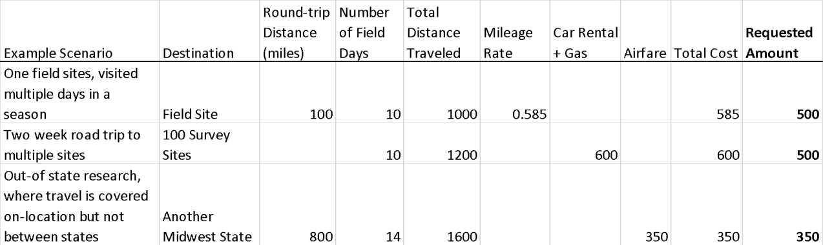
Table 1. Example budget with three scenarios

Review and Sign
- This application and the attached description have been reviewed by the PI(s) listed above. They have affirmed the accuracy of the description of the work that I will be conducting and support my application.
  - By checking this box and typing my name below, I am electronically signing this student application. PI first and last name: Click or tap here to enter text. Date: Click or tap here to enter text.
- Should I be awarded a Fueling Student Field Experiences grant, I agree to provide MWPARC with a one-page written description of the work I participated in and how it has aided in my career goals, as well as a minimum of two photographs of the field project, at least one of which includes an image of me working in the field with no site identifying features to protect study sites. These will be submitted to MWPARC by 31 October 2024, and may be used without restriction, and at no charge, by Partners in Amphibian and Reptile Conservation (PARC) on their affiliated websites, social media, and promotional materials. I agree to return my grant funds if I do not fulfill this requirement.
- By checking this box and typing my name below, I am electronically signing my application.
Student first and last name: Click or tap here to enter text. Date: Click or tap here to enter text.

Please leave blank for the MWPARC Student Travel Grant Task Team Reviewers
Does applicant meet the following criteria?
- Member of MWPARC
- Enrolled student (high school, undergraduate, or graduate) or have graduated within 1-year of the application submission date
- Research is in the Midwest U.S, is applicable towards herpetofauna conservation, and is with an established researcher (PI)
- Application is complete, description includes required information, and budget and requested amount is within application guidelines
- Has a member of the task team contacted the PI researcher for verification (student in good standing and part of the project)?
- Approved ☐ Disapproved Justification:

X
MWPARC Student Travel Grant Task Team

